Business Problem Statement
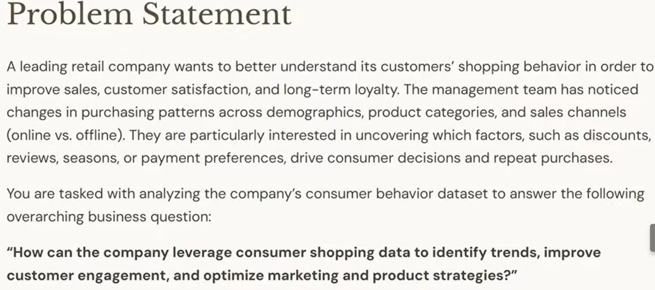
Exploratory Data Analysis using Python
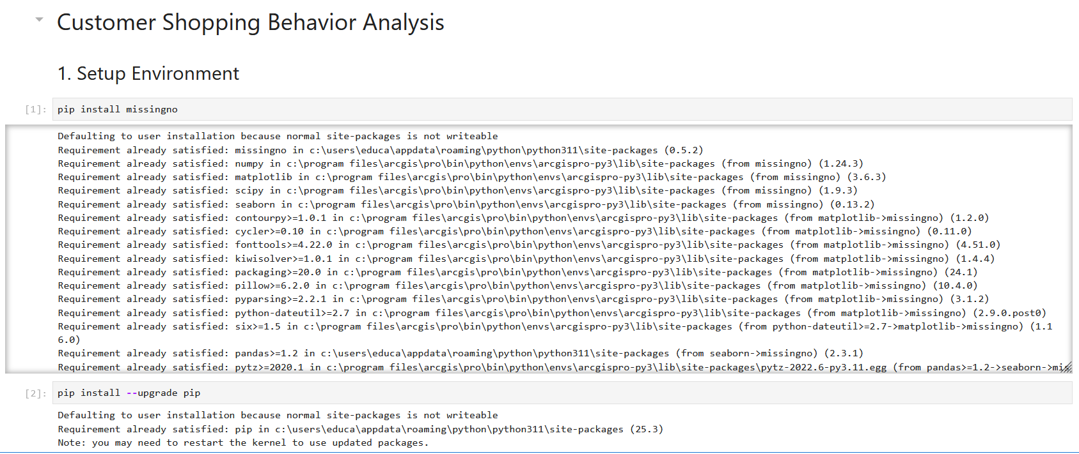
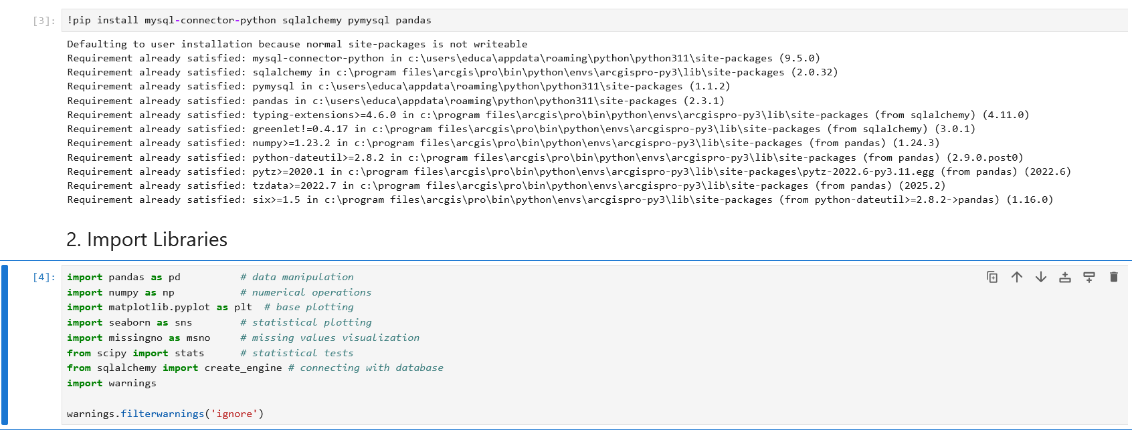
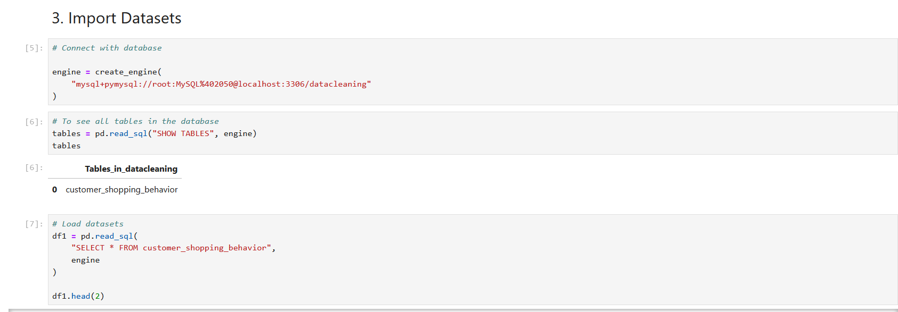
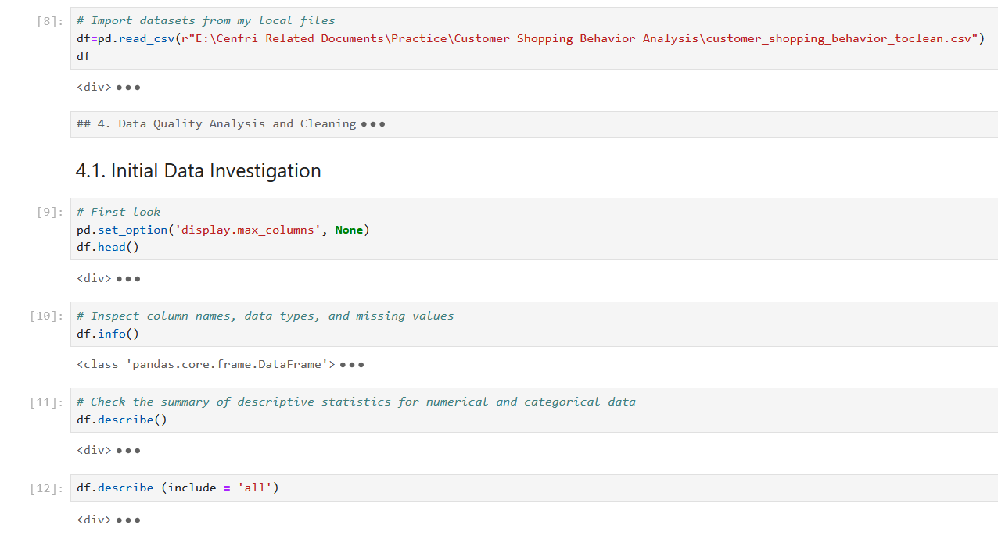
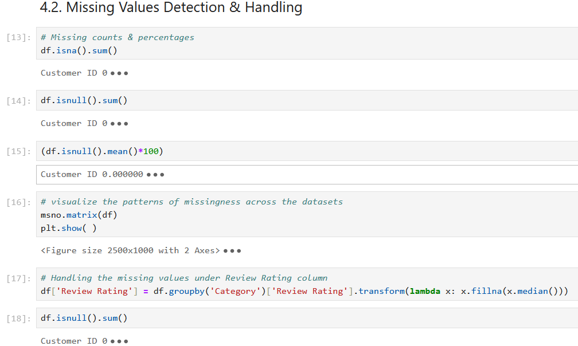
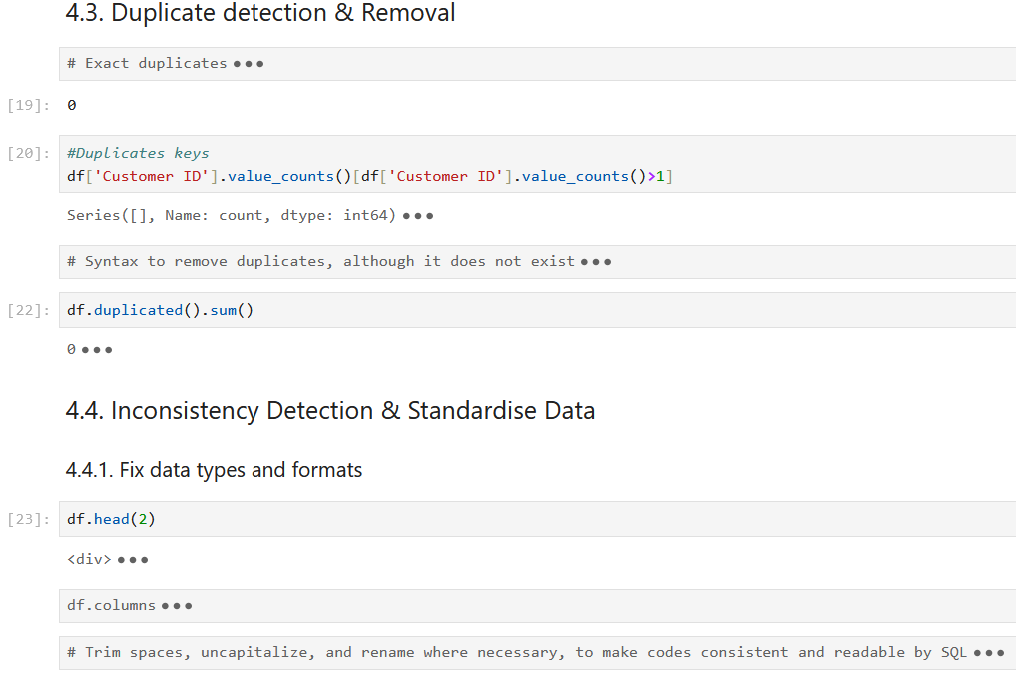
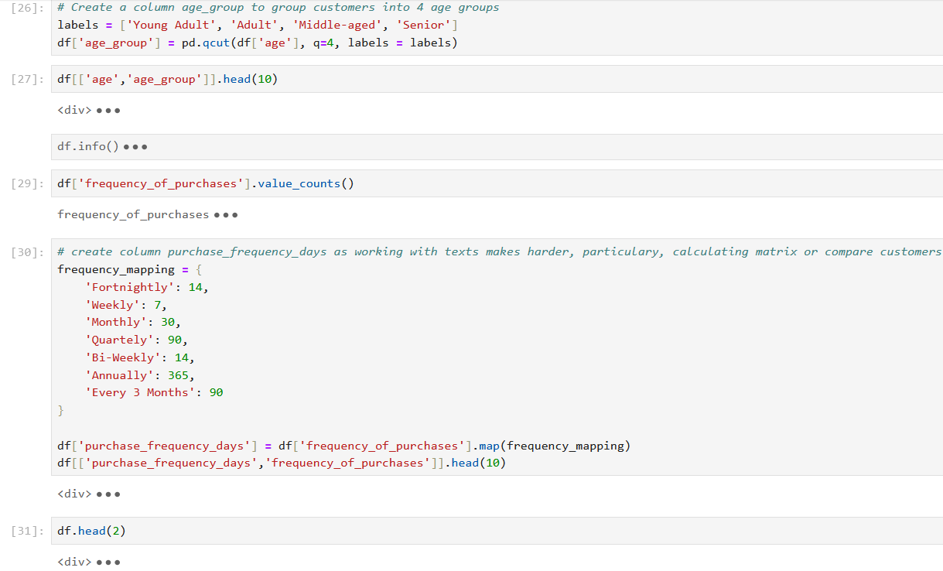
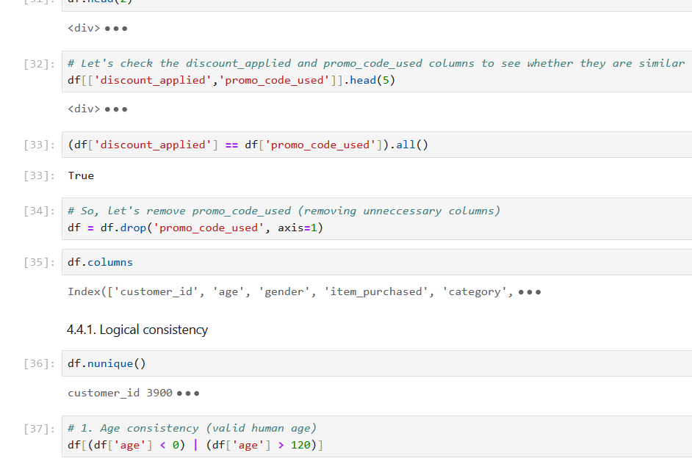
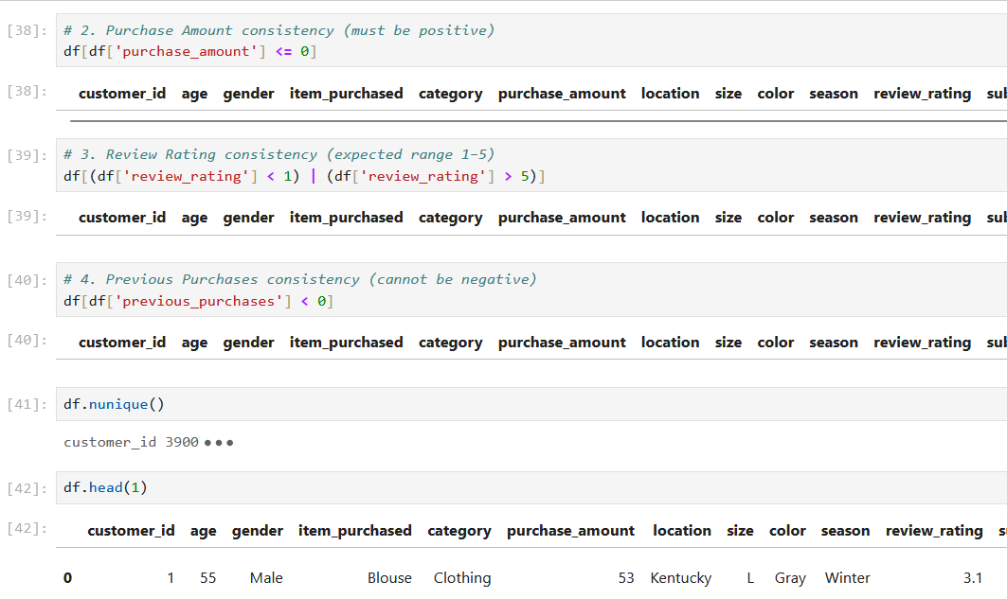
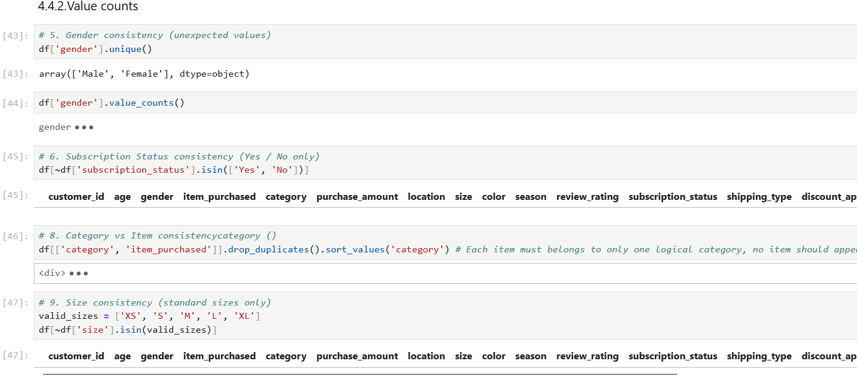
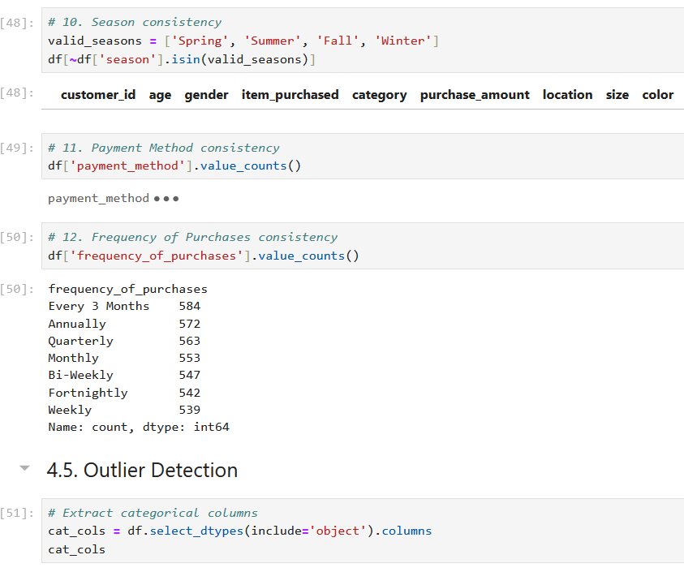
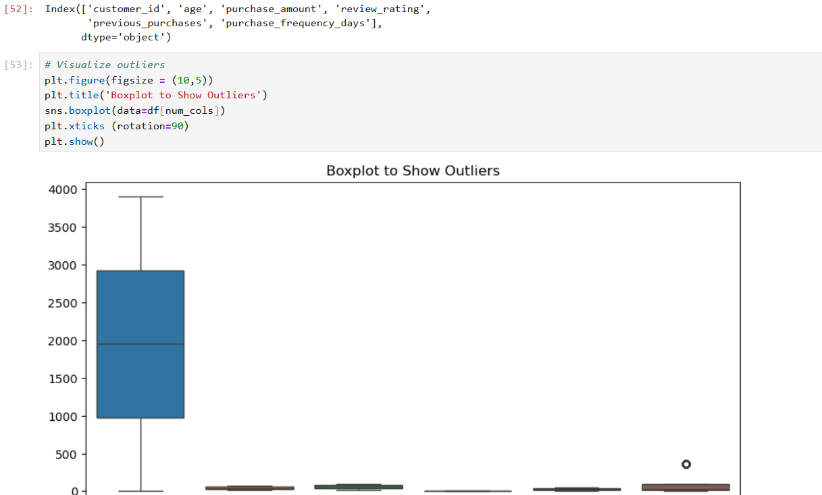
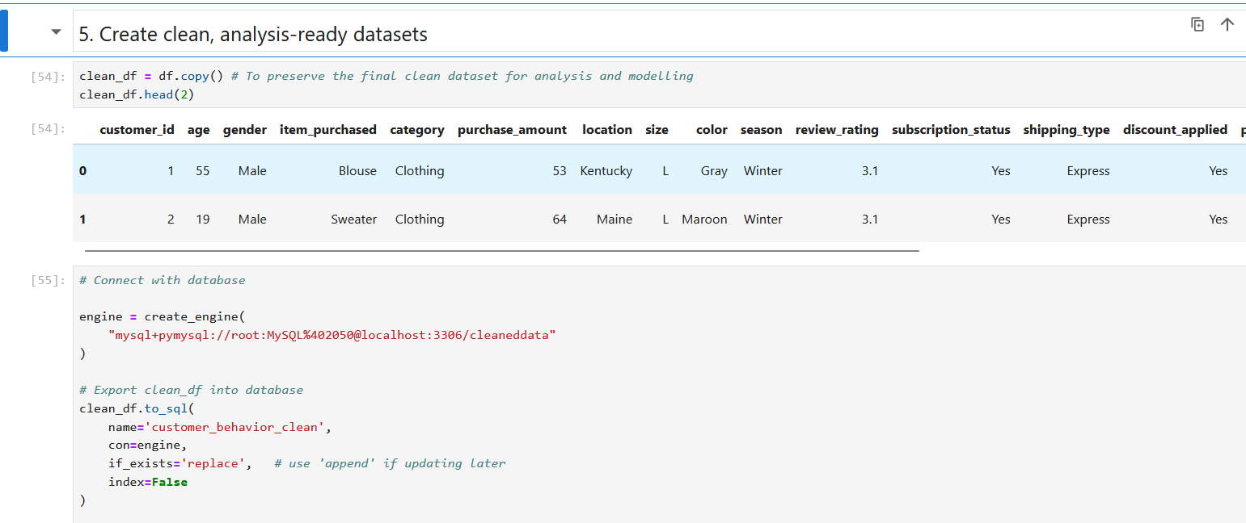
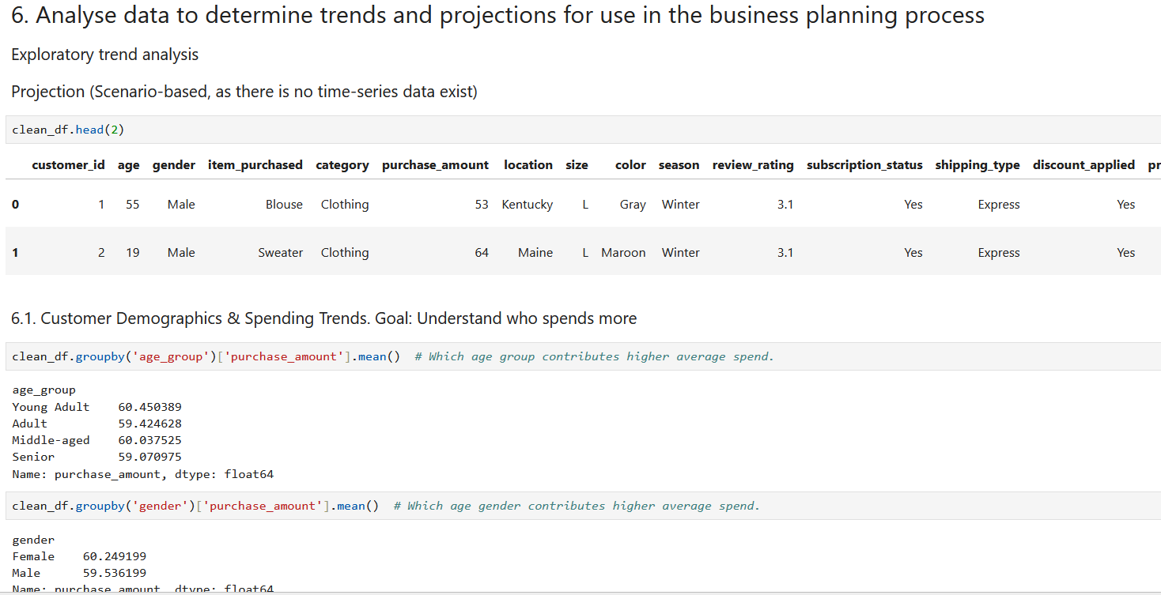
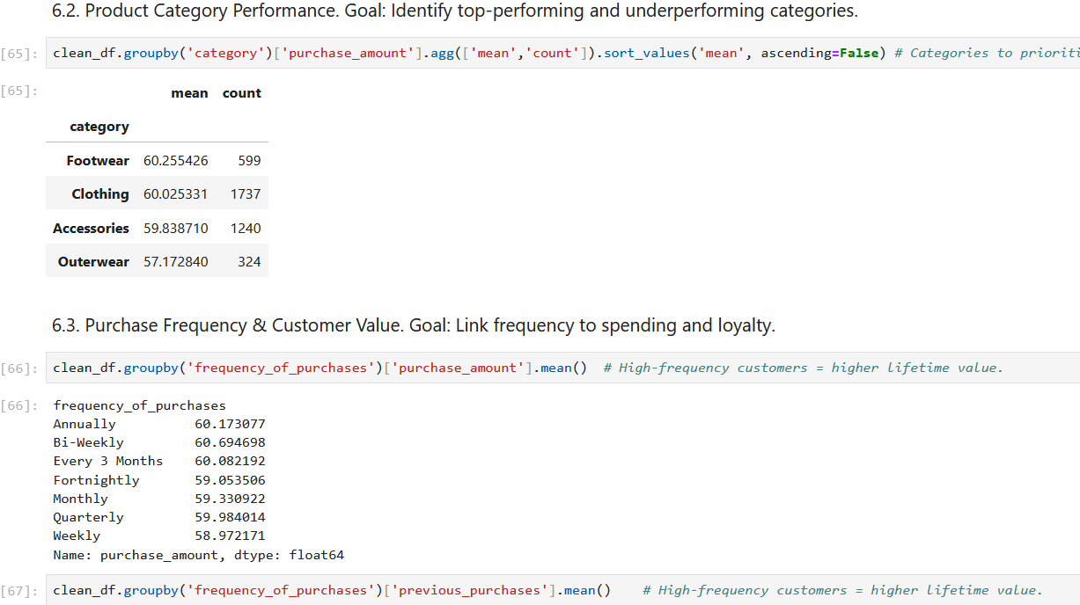
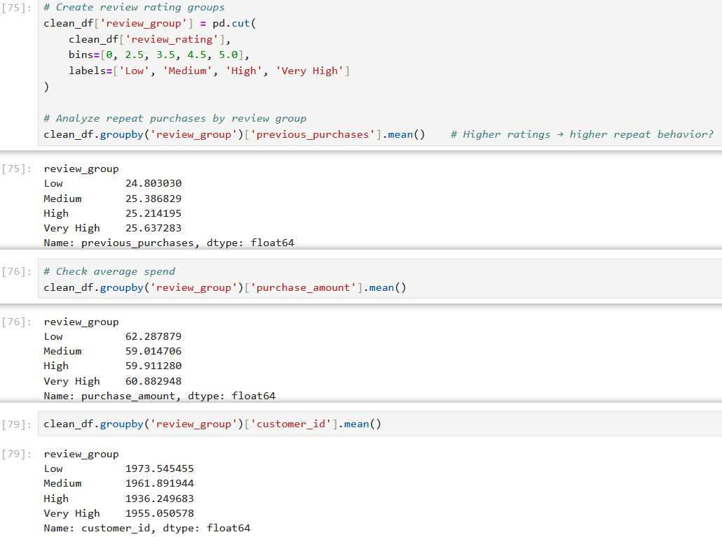
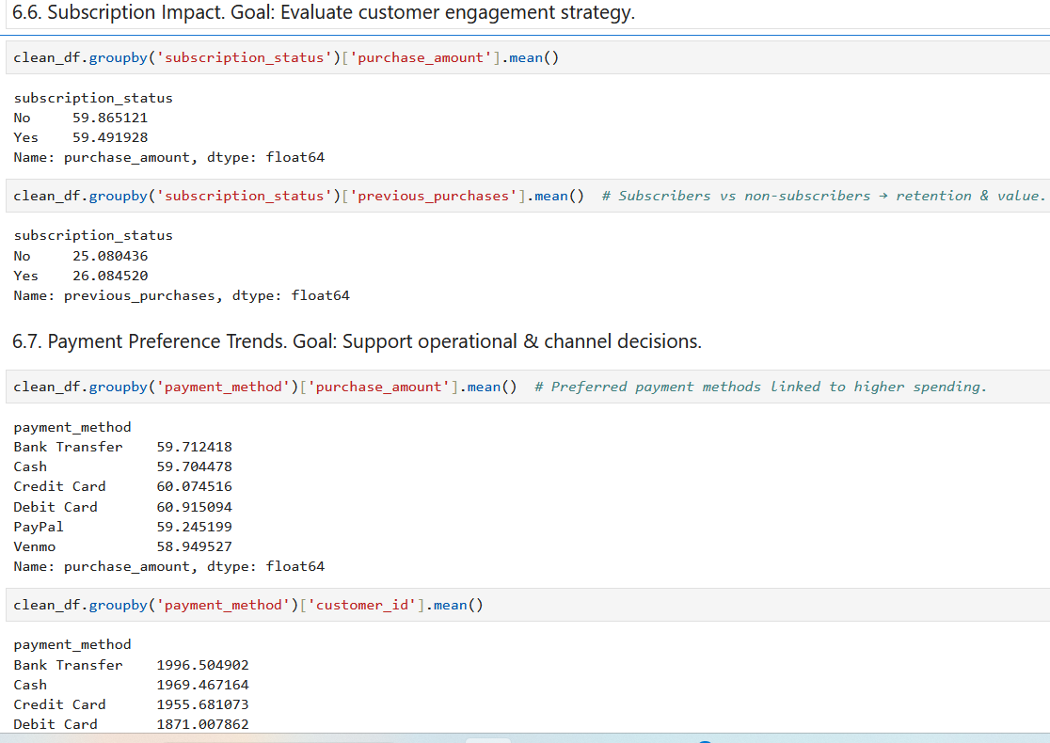
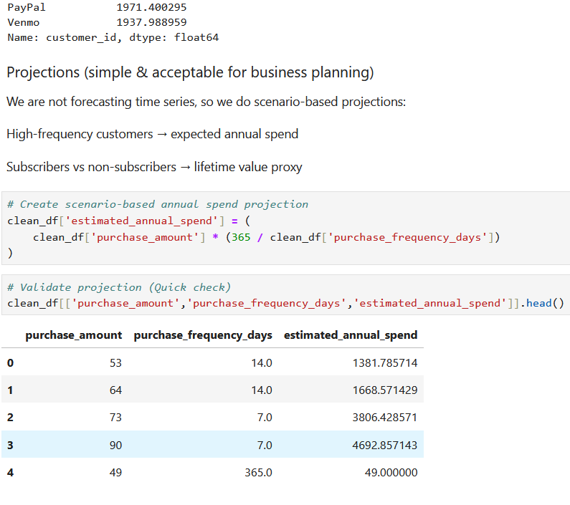
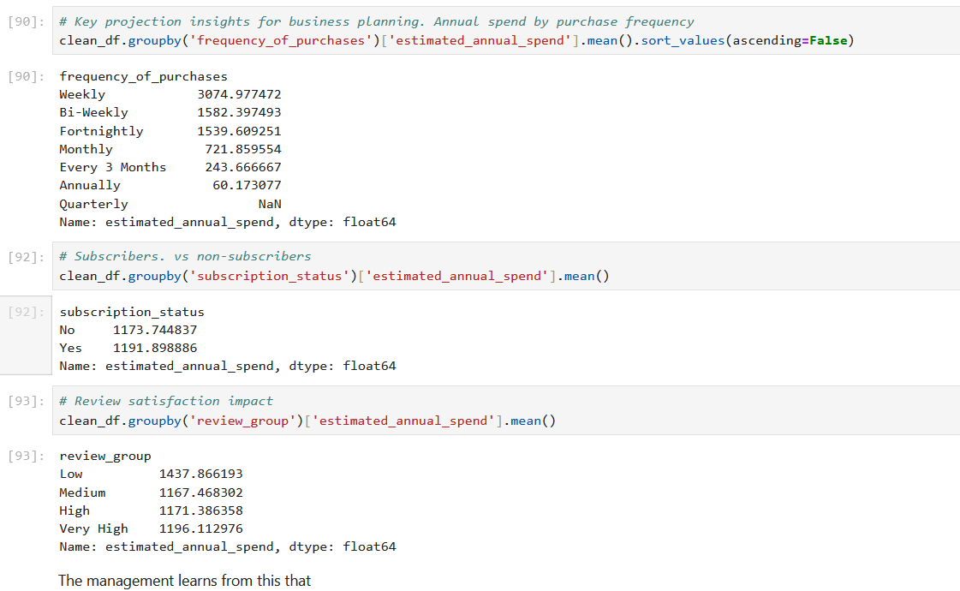
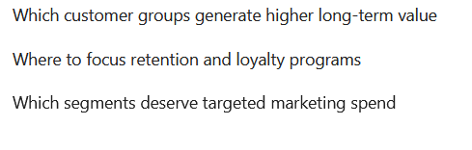

Data Analysis using SQL
Queries for Business Insights
-- Creating a database to store uncleanded and cleaned datasets
CREATE DATABASE datacleaning; -- for non-cleaned datasets
CREATE DATABASE cleaneddata; -- for cleaned datasets

-- Confirm table
SELECT *
FROM customer_behavior_clean
LIMIT 10;

-- Create a VIEW for Power BI (Which is recommedned) to keeps Power BI clean and fast
CREATE VIEW vw_customer_behavior AS
SELECT
customer_id,
age,
gender,
category,
purchase_amount,
season,
previous_purchases,
frequency_of_purchases,
purchase_frequency_days,
review_rating,
subscription_status,
discount_applied,
age_group,
payment_method

FROM customer_behavior_clean;

-- SQL queries for business insights
-- Executive KPIs
SELECT
COUNT(DISTINCT customer_id) AS total_customers,
ROUND(AVG(purchase_amount),2) AS avg_purchase_amount,
ROUND(AVG(review_rating),2) AS avg_review_rating
FROM vw_customer_behavior;
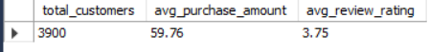

-- Agegroup-Loyality
SELECT
age_group,
ROUND(AVG(previous_purchases),2) AS avg_repeat_purchases
FROM vw_customer_behavior
GROUP BY age_group;
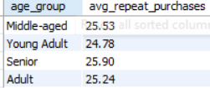

-- Category performance
SELECT
category,
ROUND(AVG(purchase_amount),2) AS avg_purchase_amount
FROM vw_customer_behavior
GROUP BY category
ORDER BY avg_purchase_amount DESC;
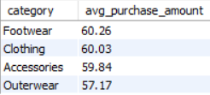

-- Q1. What is the total revenue generated by male vs. female customers?
SELECT
gender,
ROUND(SUM(purchase_amount), 2) AS total_revenue
FROM customer_behavior_clean
GROUP BY gender;
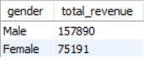

-- Q2. Which customers (SUM) used a discount but still spent more than the average purchase amount?
SELECT
COUNT(DISTINCT customer_id) AS high_value_discount_customers
FROM customer_behavior_clean
WHERE discount_applied = 'Yes'
AND purchase_amount >= (
SELECT AVG(purchase_amount)
FROM customer_behavior_clean
);
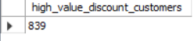

-- Q3. Which are the top 5 products with the highest average review rating?
SELECT
item_purchased,
ROUND(AVG(review_rating), 2) AS avg_review_rating
FROM customer_behavior_clean
GROUP BY item_purchased
ORDER BY avg_review_rating DESC
LIMIT 5;
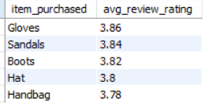

-- Q4. Compare the average purchase amounts between Standard and Express shipping.
SELECT
shipping_type,
ROUND(AVG(purchase_amount), 2) AS avg_purchase_amount
FROM customer_behavior_clean
GROUP BY shipping_type;
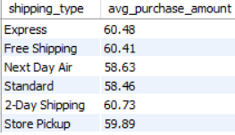

-- Q5. Do subscribed customers spend more?
-- Compare average spend and total revenue between subscribers and non-subscribers.
SELECT
subscription_status,
ROUND(AVG(purchase_amount), 2) AS avg_purchase_amount,
ROUND(SUM(purchase_amount), 2) AS total_revenue
FROM customer_behavior_clean
GROUP BY subscription_status;
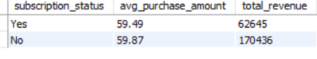

-- Q6. Which 5 products have the highest percentage of purchases with discounts applied?
SELECT
item_purchased,
ROUND(
100.0 * SUM(CASE WHEN discount_applied = 'Yes' THEN 1 ELSE 0 END) / COUNT(*),
2
) AS discount_percentage
FROM customer_behavior_clean
GROUP BY item_purchased
ORDER BY discount_percentage DESC
LIMIT 5;
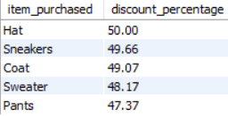

-- Q7. Segment customers into New, Returning, and Loyal based on their total number of previous purchases,
-- and show the count of each segment.
SELECT
CASE
WHEN previous_purchases = 0 THEN 'New'
WHEN previous_purchases BETWEEN 1 AND 5 THEN 'Returning'
ELSE 'Loyal'
END AS customer_segment,
COUNT(*) AS customer_count
FROM customer_behavior_clean
GROUP BY customer_segment;
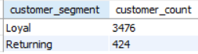

-- Q8. What are the top 3 most purchased products within each category?
SELECT category, item_purchased, purchase_count
FROM (
SELECT
category,
item_purchased,
COUNT(*) AS purchase_count,
ROW_NUMBER() OVER (
PARTITION BY category
ORDER BY COUNT(*) DESC
) AS rn
FROM customer_behavior_clean
GROUP BY category, item_purchased
) ranked
WHERE rn <= 3;
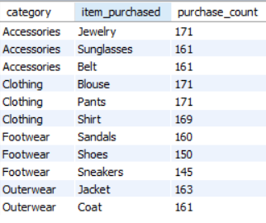

-- Q9. Are customers who are repeat buyers (more than 5 previous purchases) also likely to subscribe?
SELECT
subscription_status,
COUNT(*) AS repeat_buyers
FROM customer_behavior_clean
WHERE previous_purchases > 5
GROUP BY subscription_status;
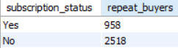

-- Q10. What is the revenue contribution of each age group?
SELECT age_group,
SUM(purchase_amount) as total_revenue
FROM customer_behavior_clean
GROUP BY age_group
ORDER BY total_revenue desc;
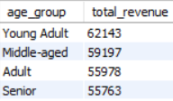

Results-Dashboard
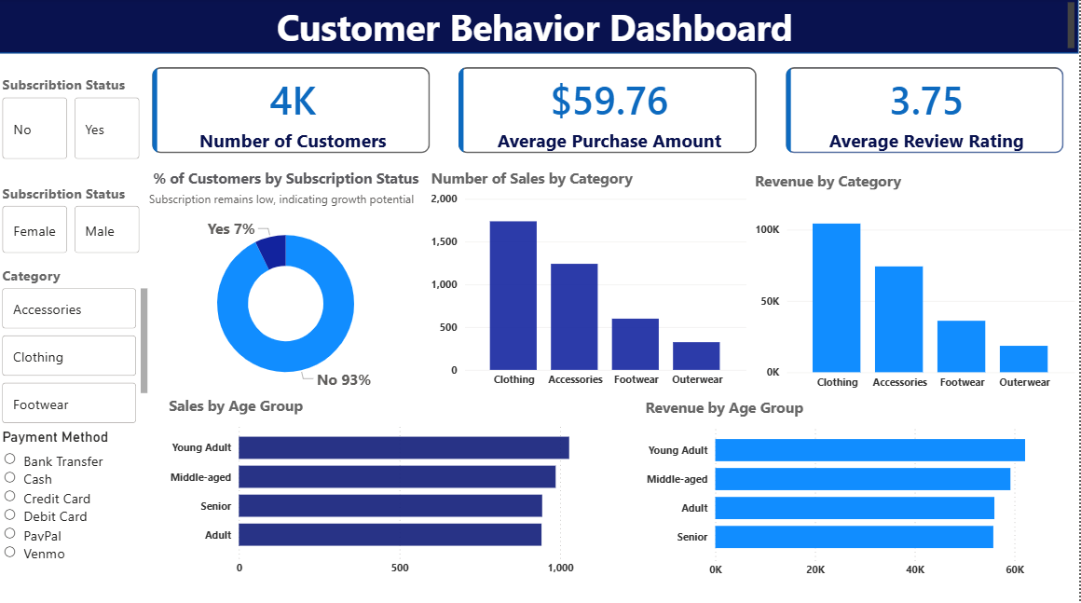
Recommendations
1️⃣ Strengthen Subscription Programs
- Subscription adoption is low compared to non-subscribers, yet subscribed customers demonstrate higher engagement and spending consistency.
- Recommendation:
Introduce incentives such as exclusive discounts, loyalty points, or free shipping to convert high-frequency and repeat customers into subscribers.

2️⃣ Focus Marketing on High-Value Age Groups
- Certain age groups contribute more revenue and repeat purchases than others.
- Recommendation:
Tailor marketing campaigns and product offerings toward these high-performing age groups to maximize return on marketing investment.

3️⃣ Optimize Product Category Strategy
- Categories such as Clothing and Accessories generate higher sales volume and revenue.
- Recommendation:
Prioritize inventory planning, promotions, and product expansion in top-performing categories while reassessing underperforming ones.

4️⃣ Use Discounts Strategically
- A segment of customers uses discounts but still spends above the average purchase amount, indicating price sensitivity does not always reduce revenue.
- Recommendation:
Apply targeted discounts to high-value or returning customers rather than broad discounting, ensuring profitability is maintained.

5️⃣ Leverage Customer Reviews to Drive Loyalty
- Higher review ratings are associated with increased repeat purchases.
- Recommendation:
Encourage customers to leave reviews through post-purchase emails or small incentives, and address negative feedback promptly to improve satisfaction and retention.

6️⃣ Strengthen Retention of Loyal Customers
- Loyal customers (those with more than five previous purchases) represent a valuable segment.
- Recommendation:
Implement loyalty programs such as tiered rewards, early access to products, or personalized offers to retain and grow this segment.

7️⃣ Align Payment and Shipping Options with Customer Preferences
- Certain payment methods and shipping types are more frequently associated with higher purchase amounts.
- Recommendation:
Ensure preferred payment methods and shipping options are always available and prominently displayed to reduce purchase friction.

By leveraging customer shopping data, the company can better identify high-value customer segments, optimize product and marketing strategies, and improve customer engagement and loyalty. The insights derived from this analysis support data-driven decision-making and provide a strong foundation for strategic business planning.

